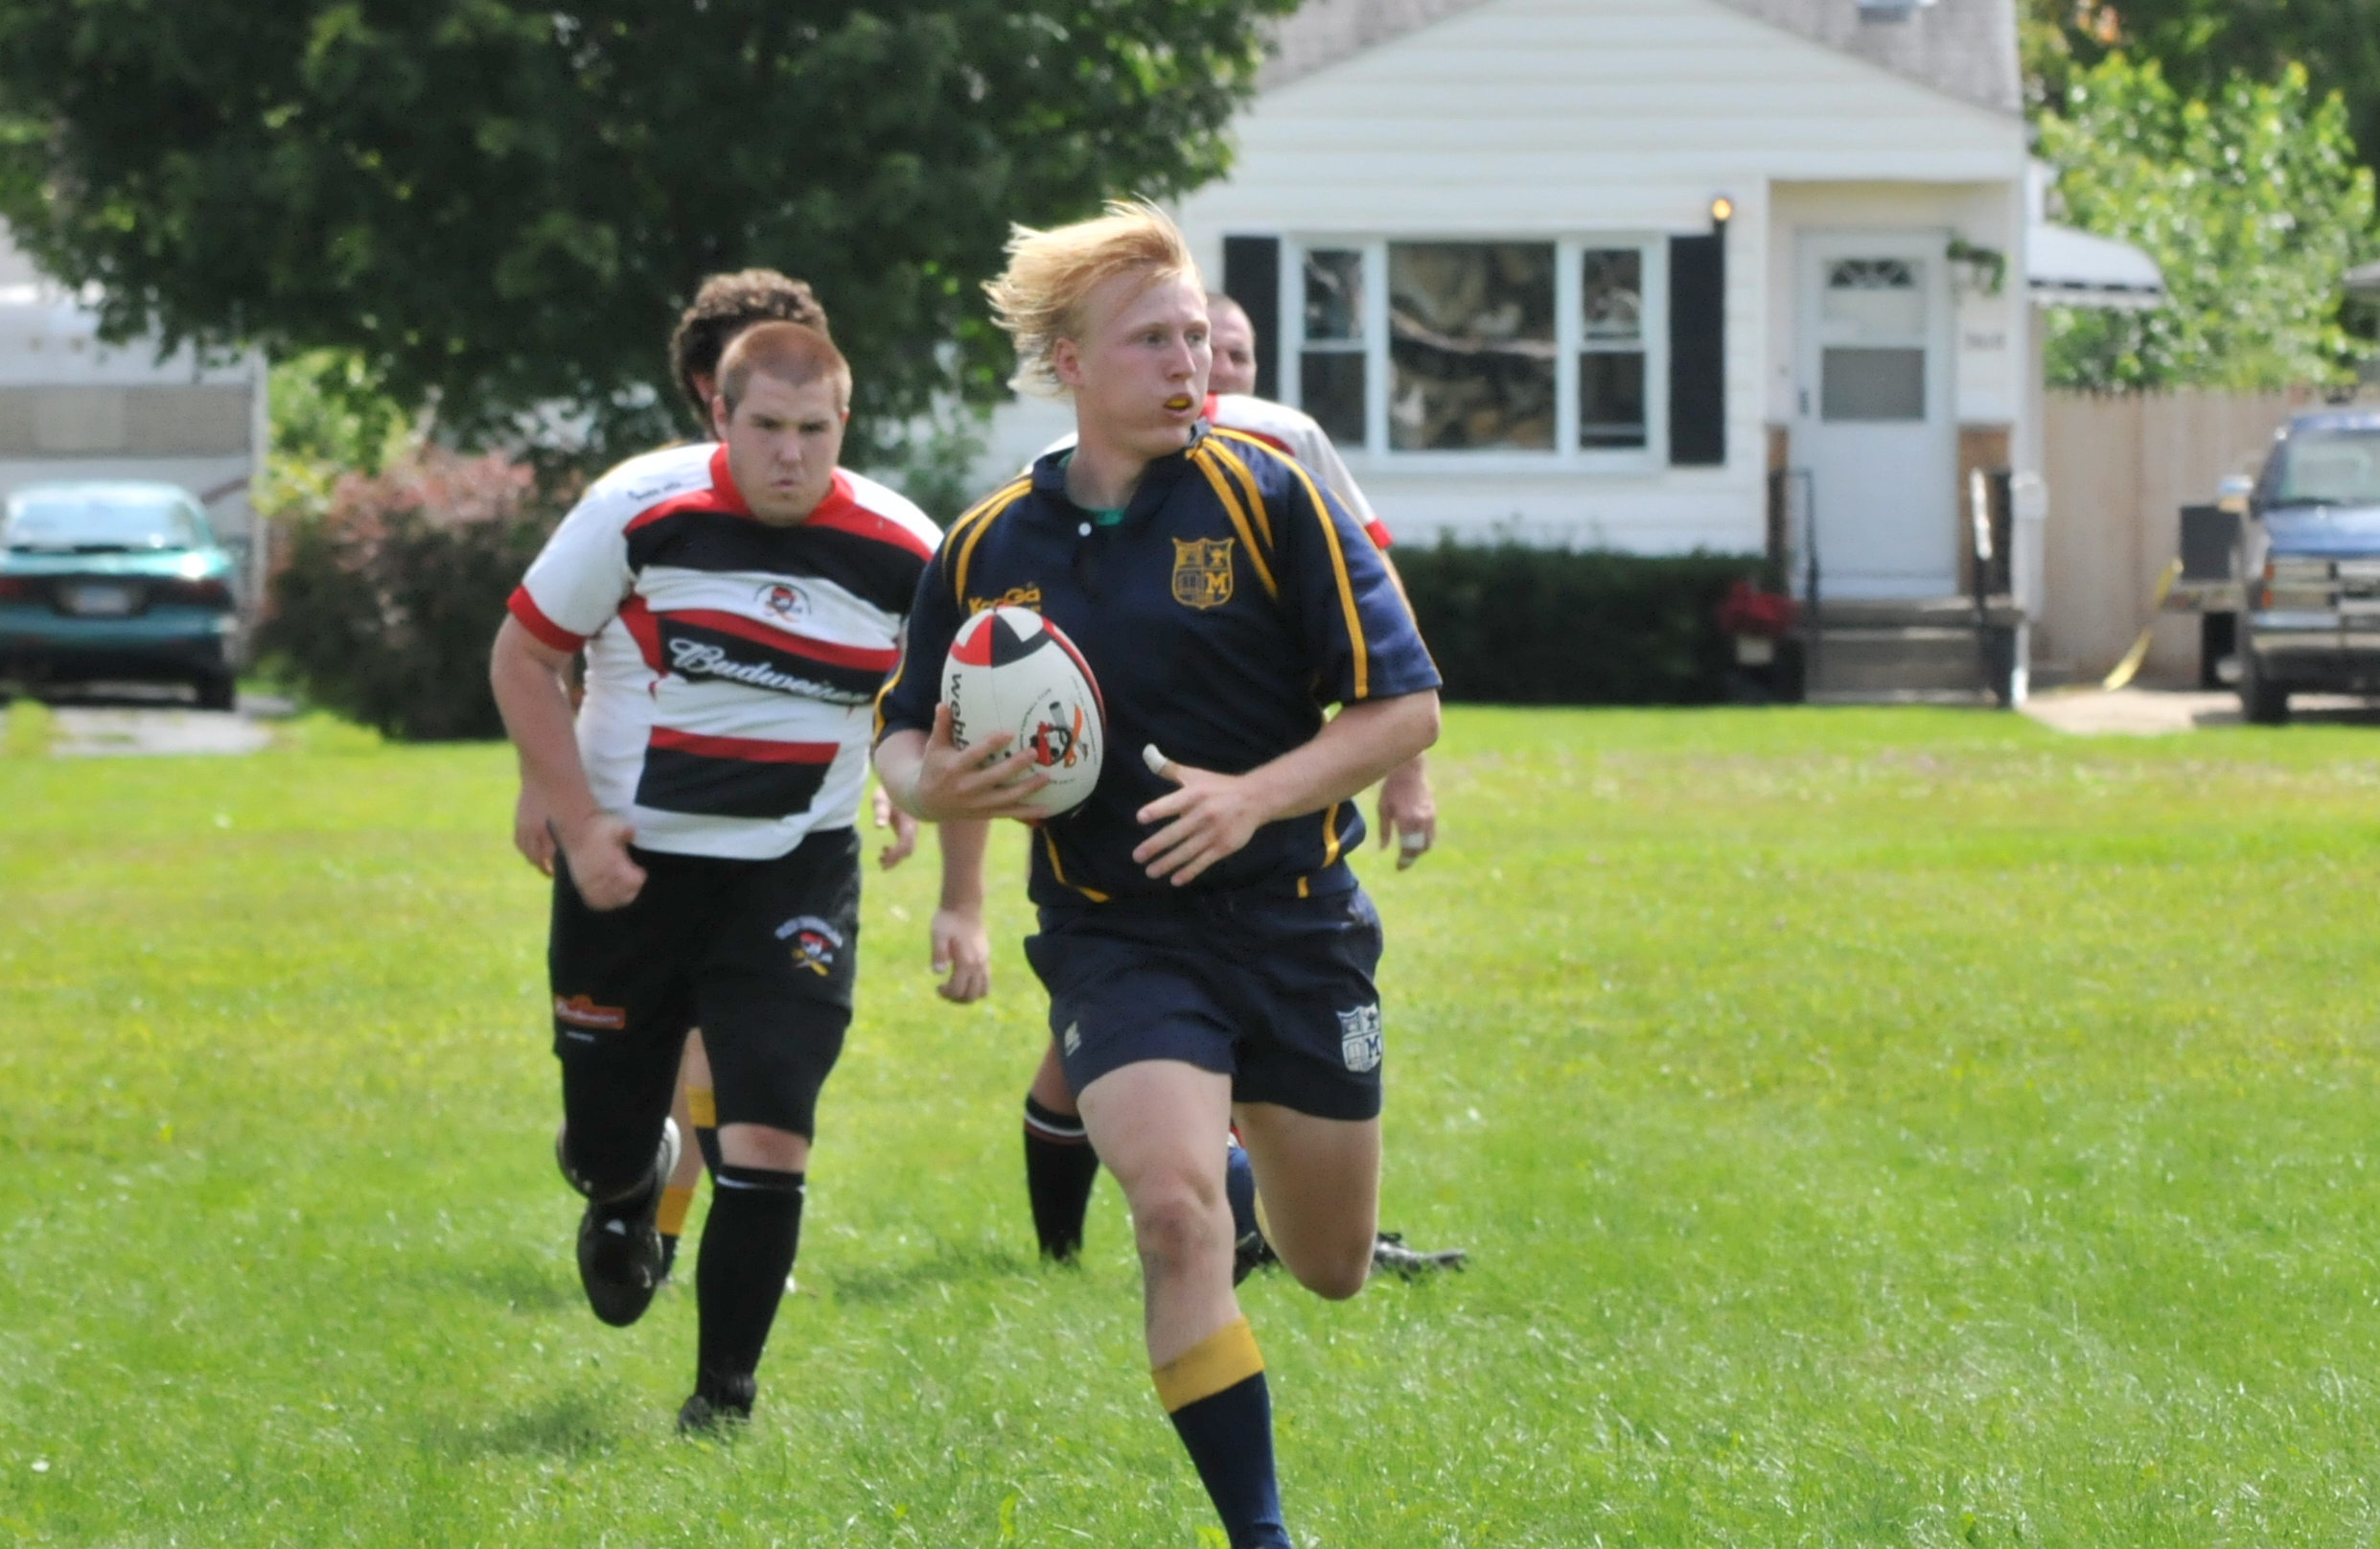

This year in PE, the students will be keeping a three week long activity log. The students will need to keep track of all of the physical activities they do outside of school to see if they are getting the recommended 30 minutes of daily exercise. This is a great opportunity to workout and bond with your child. Together, you could go for a jog, ride a bike, play a game, play catch, or simply go for a walk around the block.

Activity Log

I grew up in Lapeer and graduated from Lapeer West High School in 2004. I attended the University of Michigan, where I received my Bachelor’s degree in Physical Education, as well as a minor in Health and History. I am currently attending Western Michigan University and will be receiving my Master’s degree in Adapted Physical Education. I currently play Rugby for the Michigan Men’s Rugby Club in Ann Arbor. Rugby has allowed me to travel around the country and even out of the country. I enjoy spending time with family and friends, especially my fiancé Daniella. I am a very athletic individual whom enjoys snowboarding, skateboarding, camping, and many more sports.

## Just a little bit about Mr. Dougovito.

# About Me

* Physical Education Newsletter

###### More On Back!

Jan. 25, 2010

Lorem ipsum dolor sit amet, consectetuer adipiscing elit. Nulla lectus mi, sodales ac, consectetuer sed, luctus sit amet, risus. Mauris tempus quam sit amet mi. Mauris sagittis augue nec augue. Fusce ipsum.

Your insight into what we are doing in PE

This year I have tried to bring as many new activities and games, as well as ideas, to the classroom as I can. So far this year we have covered basketball, soccer, volleyball, racquet sports, team building activities, physical fitness activities, basic movement skills, basic nutrition, as well as how we take our heart rate and why. We have also been participating in the Presidential Challenge. So far we have done the endurance run, shuttle run, and sit and reach tests. Everyone has been doing great!

To complement the Presidential Challenge the students will be participating in some of the Fitnessgram Fitness tests. The Fitnessgram tests beginning in March, are required at the High School level to pass the mandatory 1 credit of Physical Education, and Health that are required to graduate. Exposing the students to the Fitnessgram tests now will make them better prepared for physical tests in the future. Some of the Physical Fitness tests require the student’s to peer assess one another. Through the peer assessment evaluations, students’ learn honesty, responsibility, integrity, leadership, and trustworthiness. If I ever question a student or students’ score that was given through peer evaluation, then I will personally retest them. If you would like to talk with me about your student’s progress please feel free to email me at adougovito@lapeerschools.org.

Up Coming Events!

**Jump Rope For Heart** – This year we will be doing JRFH the second week of March. Be on the lookout for more information as the event comes closer.

**Under Construction** – Mr. D is creating a website to showcase all that we do in PE. The link to the website can be found by clicking on my name in the Mayfield staff directory or by going to adougovito.weebly.com.

**Shuttle Run:**

Katlyn Caudillo 12.9s

Seth Tackett 12.4s

**Endurance Run:** *¼ Mile*

Aubrey Lubahn 1m 55s

Taylor Aguinaga 1m 55s

**Sit And Reach:**

Krystal Gates 32.5 cm

Timothy Granz 37 cm

**GREAT JOB EVERYONE!**

### What Has Been Going On This Year?

President’s Challenge

Class

Leaders