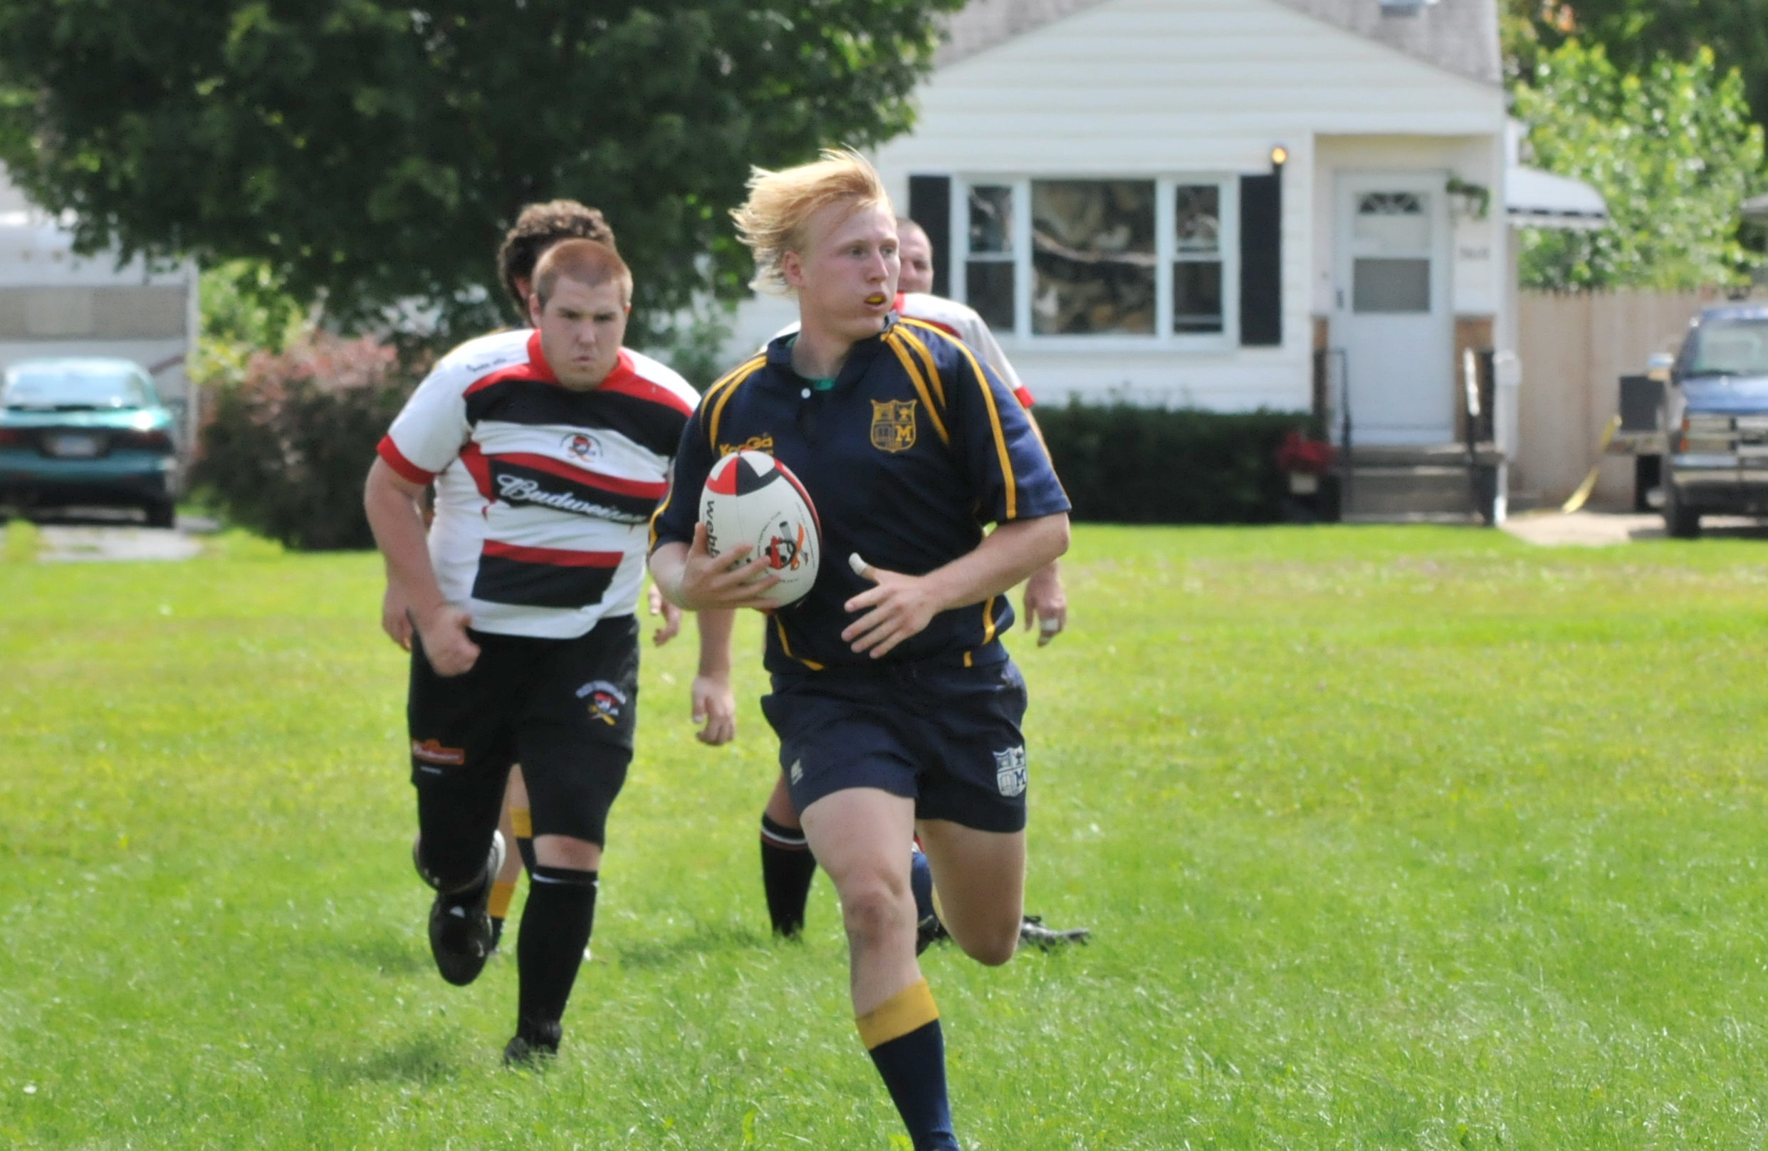

**Jump Rope For Heart** – This year we will be doing JRFH the second week of March. Be on the lookout for more information as the event comes closer.

**Under Construction** – Mr. D is creating a website to showcase all that we do in PE. The link to the website can be found by clicking on my name in the Mayfield staff directory or by going to adougovito.weebly.com.

Up Coming Events!

I grew up in Lapeer and graduated from Lapeer West High School in 2004. I attended the University of Michigan, where I received my Bachelor’s degree in Physical Education, as well as a minor in Health and History. I am currently attending Western Michigan University and will be receiving my Master’s degree in Adapted Physical Education. I currently play Rugby for the Michigan Men’s Rugby Club in Ann Arbor. Rugby has allowed me to travel around the country and even out of the country. I enjoy spending time with family and friends, especially my fiancé Daniella. I am a very athletic individual whom enjoys snowboarding, skateboarding, camping, and many more sports.

## Just a little bit about Mr. Dougovito.

# About Me

* Physical Education Newsletter

Jan. 25, 2010

Lorem ipsum dolor sit amet, consectetuer adipiscing elit. Nulla lectus mi, sodales ac, consectetuer sed, luctus sit amet, risus. Mauris tempus quam sit amet mi. Mauris sagittis augue nec augue. Fusce ipsum.

Your insight into what we are doing in PE