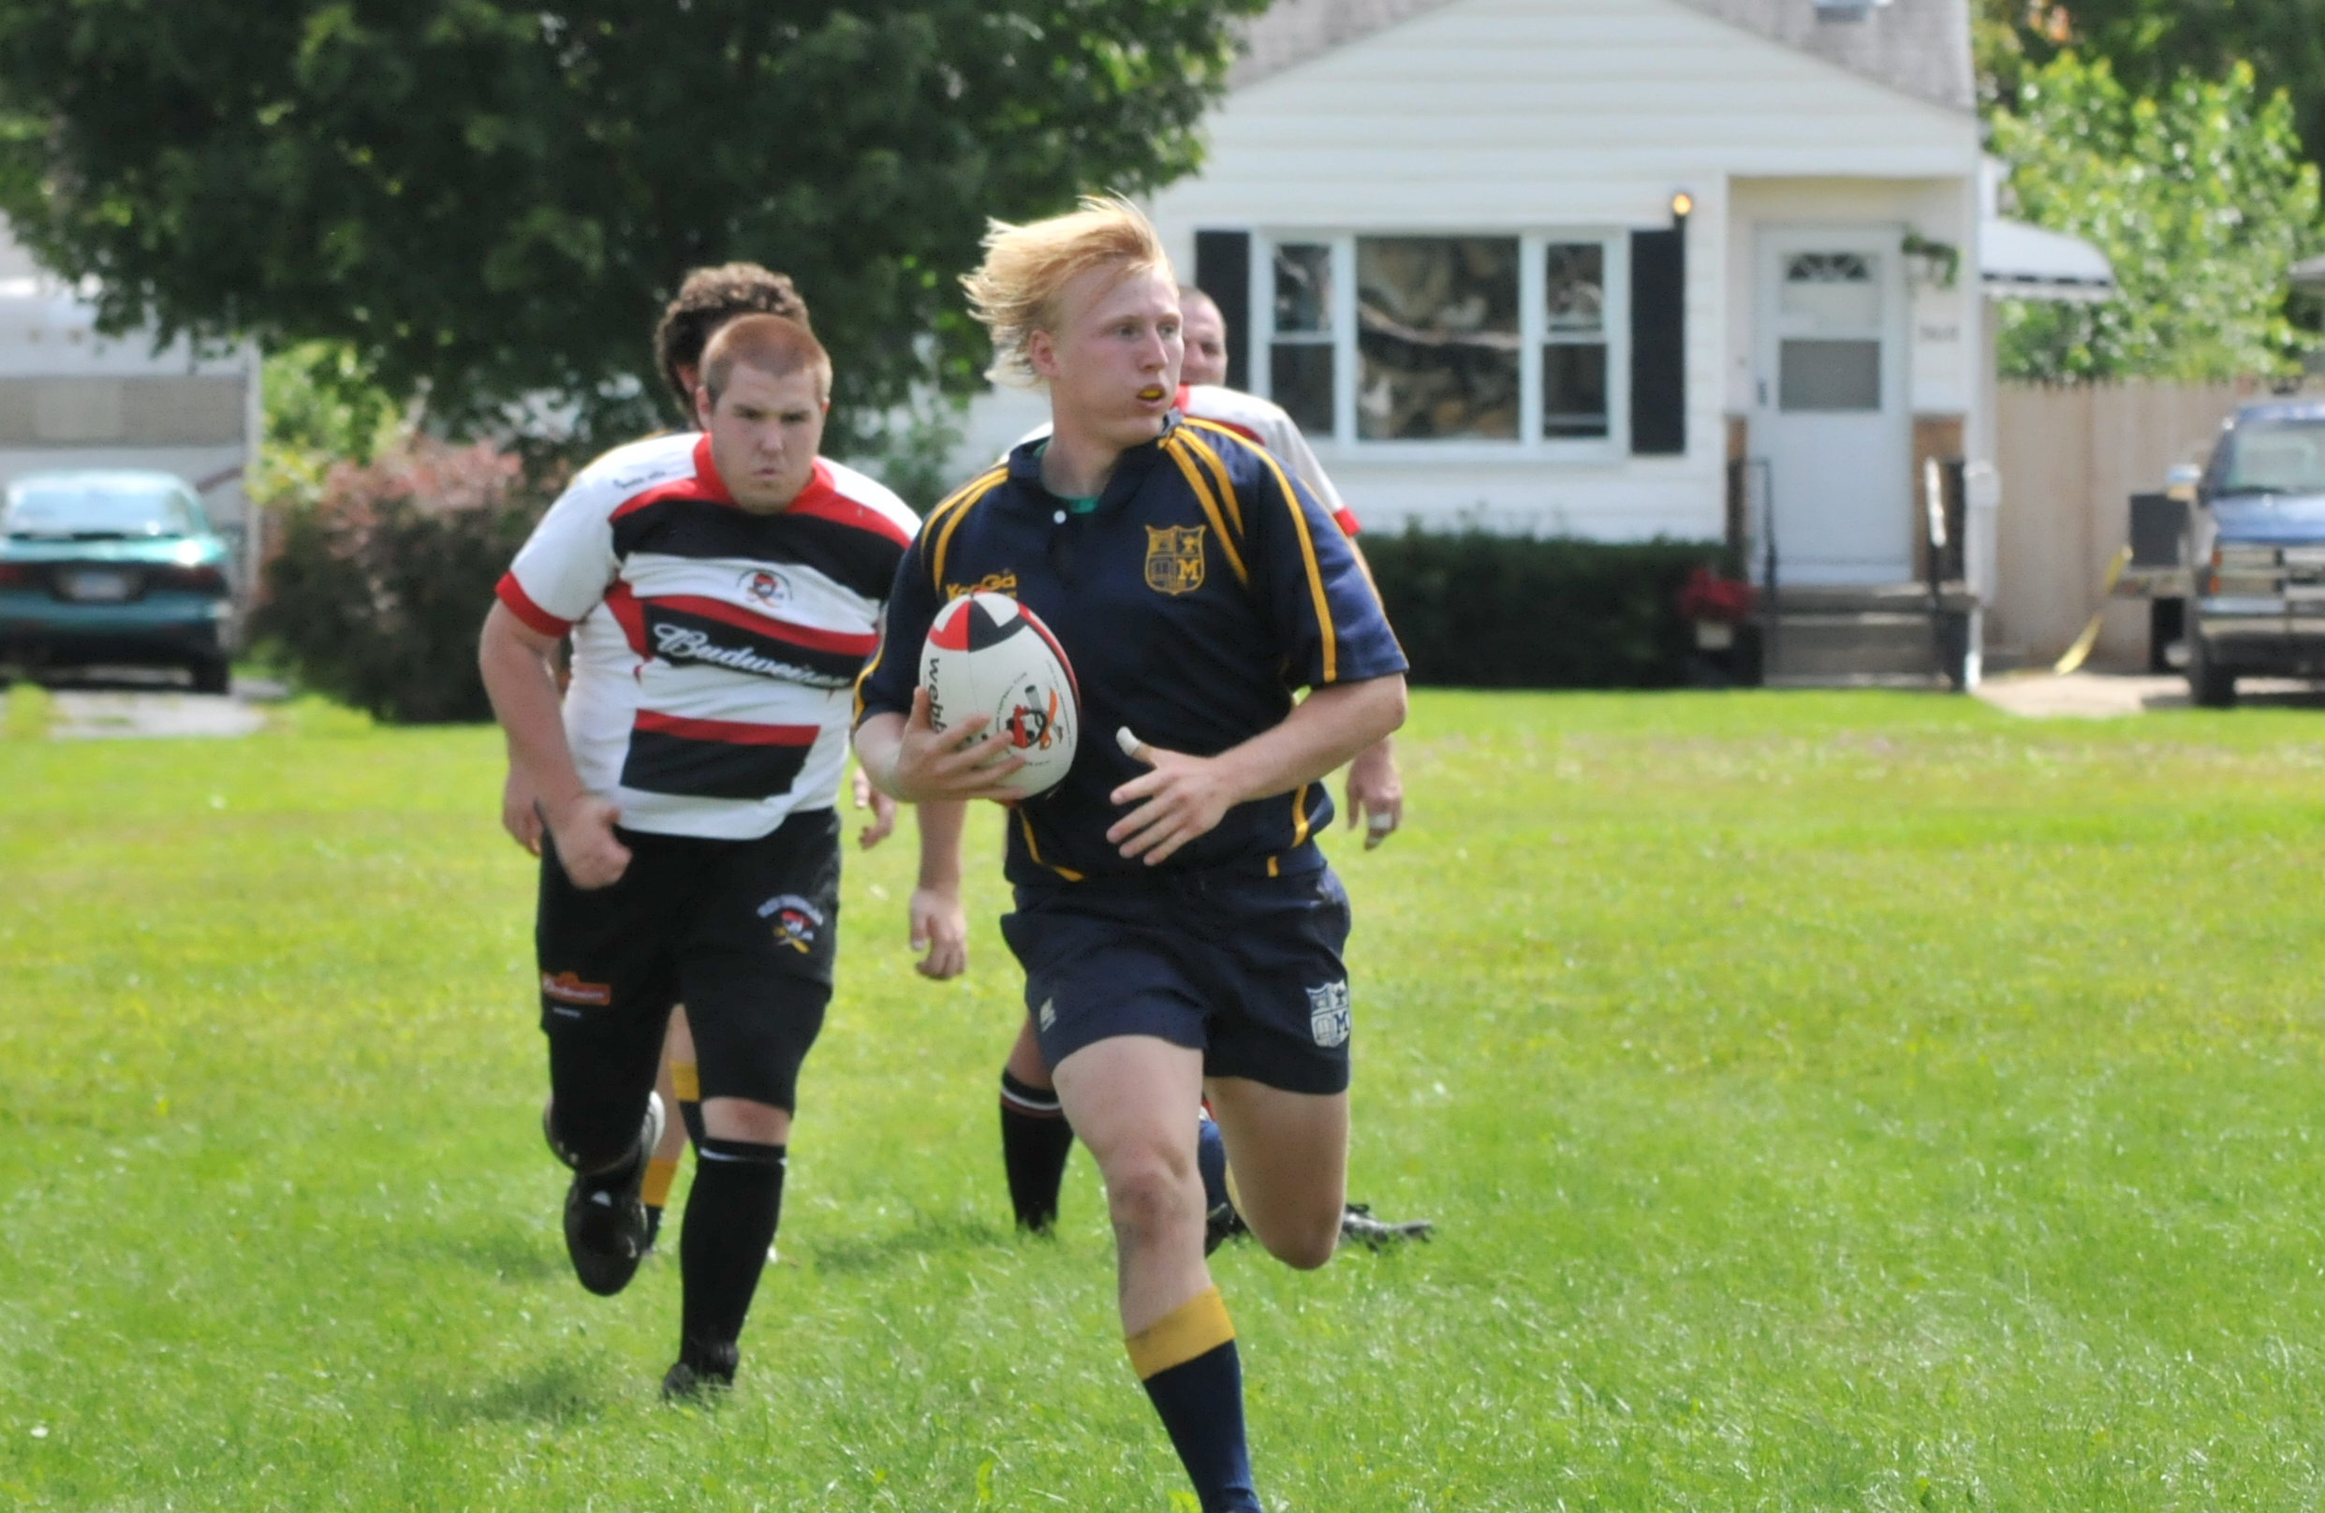

This year in PE, the students will be keeping a three week long activity log. The students will need to keep track of all of the physical activities they do outside of school to see if they are getting the recommended 30 minutes of daily exercise. This is a great opportunity to workout and bond with your child. Together, you could go for a jog, ride a bike, play a game, play catch, or simply go for a walk around the block.

Activity Log

I grew up in Lapeer and graduated from Lapeer West High School in 2004. I attended the University of Michigan, where I received my Bachelor’s degree in Physical Education, as well as a minor in Health and History. I am currently attending Western Michigan University and will be receiving my Master’s degree in Adapted Physical Education. I currently play Rugby for the Michigan Men’s Rugby Club in Ann Arbor. Rugby has allowed me to travel around the country and even out of the country. I enjoy spending time with family and friends, especially my fiancé Daniella. I am a very athletic individual whom enjoys snowboarding, skateboarding, camping, and many more sports.

## Just a little bit about Mr. Dougovito.

# About Me

* Physical Education Newsletter

###### More On Back!

Jan. 25, 2010

Lorem ipsum dolor sit amet, consectetuer adipiscing elit. Nulla lectus mi, sodales ac, consectetuer sed, luctus sit amet, risus. Mauris tempus quam sit amet mi. Mauris sagittis augue nec augue. Fusce ipsum.

Your insight into what we are doing in PE

This year I have tried to bring as many new activities and games, as well as ideas, to the classroom as I can. So far this year we have covered basketball, soccer, volleyball, racquet sports, team building activities, physical fitness activities, basic movement skills, basic nutrition, as well as how we take our heart rate and why. We have also been participating in the Presidential Challenge. So far we have done the endurance run, shuttle run, and sit and reach tests. Everyone has been doing great!

To complement the Presidential Challenge the students will be participating in some of the Fitnessgram Fitness tests. The Fitnessgram tests begining in March, are required at the High School level to pass the mandatory 1 credit of Physical Education, and Health that are required to graduate. Exposing the students to the Fitnessgram tests now will make them better prepared for physical tests in the future. Some of the Physical Fitness tests require the student’s to peer assess one another. Through the peer assessment evalutations, students’ learn honesty, responsibility, integrity, leadership, and trustworthiness. If I ever question a student or students’ score that was given through peer evaluation, then I will personally retest them. If you would like to talk with me about your student’s progress please feel free to email me at adougovito@lapeerschools.org.

**Jump Rope For Heart** – This year we will be doing JRFH the second week of March and the kick off assembly will be Monday, February 22nd. Be on the lookout for more information as the event comes closer.

**Mayfield Running Club** – Calling all runners, Mayfield is starting a running club. Keep your eyes open for a flyer coming home soon!

**Under Construction** – Mr. D is creating a website to showcase all that we do in PE. The link to the website can be found by clicking on my name in the Mayfield staff directory or by going to adougovito.weebly.com.

**Shuttle Run:**

1st Timmy O’Neill 13.1s

Austin Turner 13.1s

Emma Muir 12.6s

2nd Alex Chevrette 12.6s

Kylie Evans 12.6s

3rd Jacob Whitney 11.4s

Mathew Weeks 11.4s

Heather Crutchfield 12.5s

4th Drew Knickerbocker 10.5s

Racheal Ritter 11.8s

5th Tirstan Walters 10.0s

Tori Tripp 10.8s

6th Bryan Barber 9.8s

Jessica Monfort 10.8s

**Endurance Run:**

*¼ Mile Run*

1st Timmy O’Neill 1m 40s

Lola Flynn 2m 05s

2nd  Tyler Mauk 1m 40s

Audrey Morford 1m 50s

*½ Mile Run*

3rd Jacob Mueler 3m 41s

Madison McAley 4m 15s

4th Drew Knickerbocker 3 m 21s

Julia Jackson 4m 53s

*1 Mile Run*

5th Timothy Weeks 8m 39s

Lyndsay Westphal 8m 41s

6th Zach Roach 7m 32s

Ashley Robinson 9m 36s

**Sit And Reach:**

1st Brandon Dickinson 41.5 cm

Ella Coulter 35.5 cm

2nd Brandon St. Louis 36 cm

Karissa Pringle 35 cm

3rd Shane Welch 41 cm

Mahlea Maresh 42.5 cm

4th Ethan Sanford 38 cm

Macie Taylor 41 cm

5th Joe Minuado 41 cm

Tori Tripp 38 cm

Kelsey Welch 38 cm

6th Rion Stevens 38 cm

Adrianna Rukenbrod 47 cm

**GREAT JOB EVERYONE!**

Up Coming Events!

### What Has Been Going On This Year?

President’s Challenge

Grade

Leaders